**Topics: Descriptive Statistics and Probability**

1. Look at the data given below. Plot the data, find the outliers and find out $μ, σ, σ^{2}$

|  |  |
| --- | --- |
| **Name of company** | **Measure X** |
| Allied Signal | 24.23% |
| Bankers Trust | 25.53% |
| General Mills | 25.41% |
| ITT Industries | 24.14% |
| J.P.Morgan & Co. | 29.62% |
| Lehman Brothers | 28.25% |
| Marriott | 25.81% |
| MCI | 24.39% |
| Merrill Lynch | 40.26% |
| Microsoft | 32.95% |
| Morgan Stanley | 91.36% |
| Sun Microsystems | 25.99% |
| Travelers | 39.42% |
| US Airways | 26.71% |
| Warner-Lambert | 35.00% |

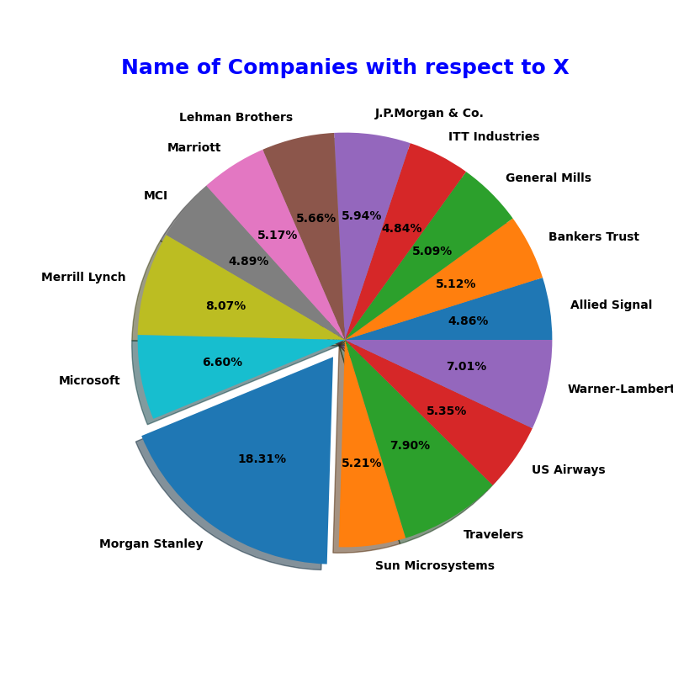

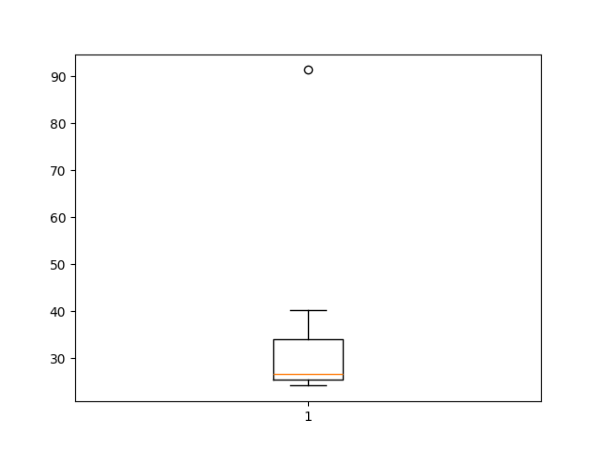

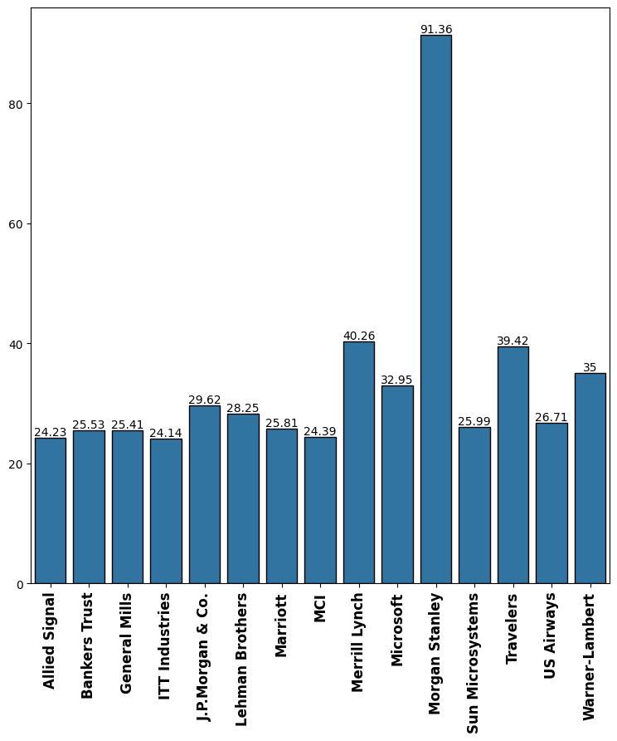

Therefore, the outlier is: Morgan Stanley

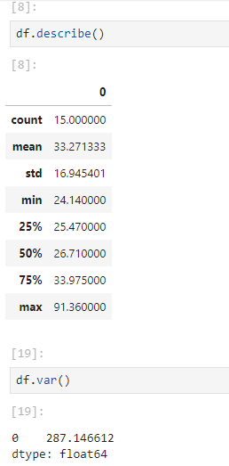



Answer the following three questions based on the box-plot above.

1. What is inter-quartile range of this dataset? (please approximate the numbers) In one line, explain what this value implies.

Here, first quartile range, Q1 = 5 and third quartile range, Q3 = 12 (approximately)

Therefore, inter-quartile range = Q3 – Q1 = 12 – 5 = 7

This implies that, 50% of the data lies within 5 and 12. It is the measure of the spread of the middle 50% of the data, which unlike the range of the data, is free from the effects of the outliers in the dataset.

1. What can we say about the skewness of this dataset?

The data is right-skewed, so it is not a normal distribution

1. If it was found that the data point with the value 25 is actually 2.5, how would the new box-plot be affected?

If, 25 is replaced with 2.5, then first, there would not be any outlier. Second, Q1, Q2, and Q3 will shift slightly towards the left.

And might also reduce the skewness of the data.



Answer the following three questions based on the histogram above.

1. Where would the mode of this dataset lie?

Mode of the dataset lies between 4 and 8

1. Comment on the skewness of the dataset.

The dataset is right-skewed

1. Suppose that the above histogram and the box-plot in question 2 are plotted for the same dataset. Explain how these graphs complement each other in providing information about any dataset.

From the boxplot we know Q1, Q2, Q3 and min and max, and from the histogram we know the frequency distribution. So, we can tell how many values lied between within inter-quartile range.

Other than that, median is clearly visible in the boxplot and mode is clearly visible in the histogram.

Skewness can be inferred from both.

1. AT&T was running commercials in 1990 aimed at luring back customers who had switched to one of the other long-distance phone service providers. One such commercial shows a businessman trying to reach Phoenix and mistakenly getting Fiji, where a half-naked native on a beach responds incomprehensibly in Polynesian. When asked about this advertisement, AT&T admitted that the portrayed incident did not actually take place but added that this was an enactment of something that “could happen.” Suppose that one in 200 long-distance telephone calls is misdirected. What is the probability that at least one in five attempted telephone calls reaches the wrong number? (Assume independence of attempts.)

Here, we have a question of binomial distribution.

So, probability of success (wrong phone call), p = 1/200

And therefore, q = 199/200

Hence, p(of at least 1 in 5 attempted calls reaches the wrong number) = ${ ^{5}C}_{1}{\left(\frac{1}{200}\right)}^{1}{\left(\frac{199}{200}\right)}^{4}+ { ^{5}C}_{2}{\left(\frac{1}{200}\right)}^{2}{\left(\frac{199}{200}\right)}^{3}+ { ^{5}C}_{1}{\left(\frac{1}{200}\right)}^{3}{\left(\frac{199}{200}\right)}^{2}+ { ^{5}C}_{1}{\left(\frac{1}{200}\right)}^{4}{\left(\frac{199}{200}\right)}^{1}+ { ^{5}C}_{1}{\left(\frac{1}{200}\right)}^{5}{\left(\frac{199}{200}\right)}^{0}$

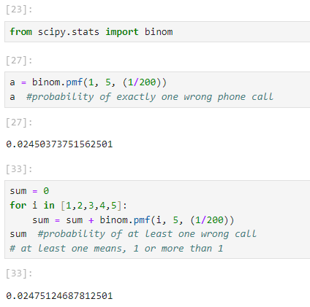

1. Returns on a certain business venture, to the nearest $1,000, are known to follow the following probability distribution

|  |  |
| --- | --- |
| x | P(x) |
| -2,000 | 0.1 |
| -1,000 | 0.1 |
| 0 | 0.2 |
| 1000 | 0.2 |
| 2000 | 0.3 |
| 3000 | 0.1 |

1. What is the most likely monetary outcome of the business venture?

The most likely monetary outcome of the business venture is $2000, as it has the highest probability (0.3).

1. Is the venture likely to be successful? Explain

The probability of making a profit (0 or more than 0) is p(x >0) + p(x >1000) + p(x >2000) + p(x >3000) = 0.2 + 0.2 + 0.3 + 0.1 = 0.8

Which means 80% chance of making a profit. Therefore, it will be successful!

1. What is the long-term average earning of business ventures of this kind? Explain

To calculate the long-term average earning, we need to calculate the expected value.

$$E\left[X\right]= \sum_{i}{x_{i}}*P(X= x_{i})$$

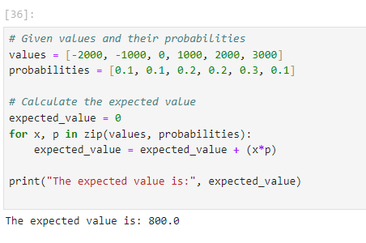

1. What is the good measure of the risk involved in a venture of this kind? Compute this measure

Good measure of the risk involved in the venture is variance. Higher the variance, greater the risk involved.

$$Var\left(X\right)=E\left[X^{2}\right]-E{\left[X\right]}^{2}$$

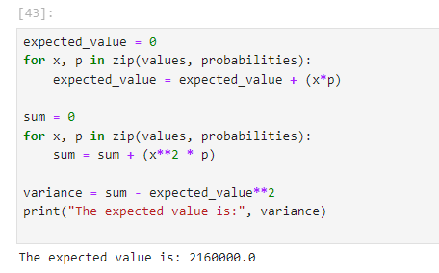

So, we can say that the venture is quite risky!